**Create And Configure IBM Cloud Service**

**Create A Database in Cloudant DB**

|  |  |
| --- | --- |
| **Date** | **29 October 2022** |
| **Team ID** | **PNT2022TMID07381** |
| **Project Name** | |  | | --- | | Personal Assistance For Seniors Who Are Self-Reliant | |  | |
| **Maximum Marks** | **4 Marks** |

**AIM**

To create a database in Cloudant DB to store location data

# STEPS

1.Login to IBM Cloud with smart internz mail ID and Password.

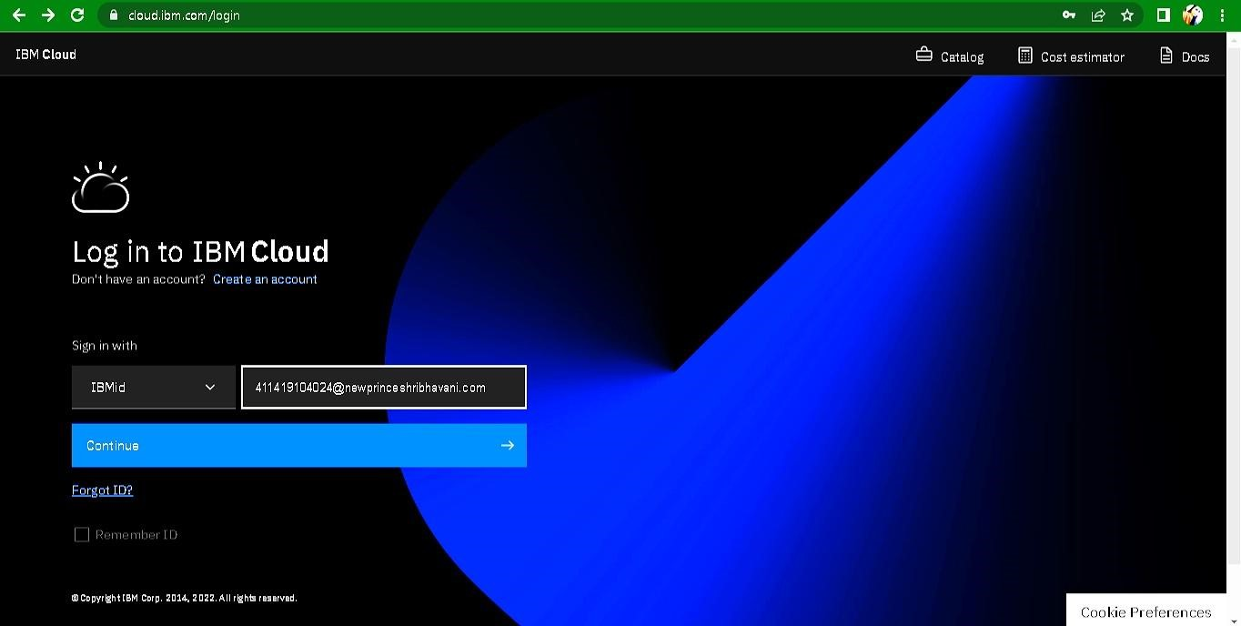

1. Click “Create Resource +” button

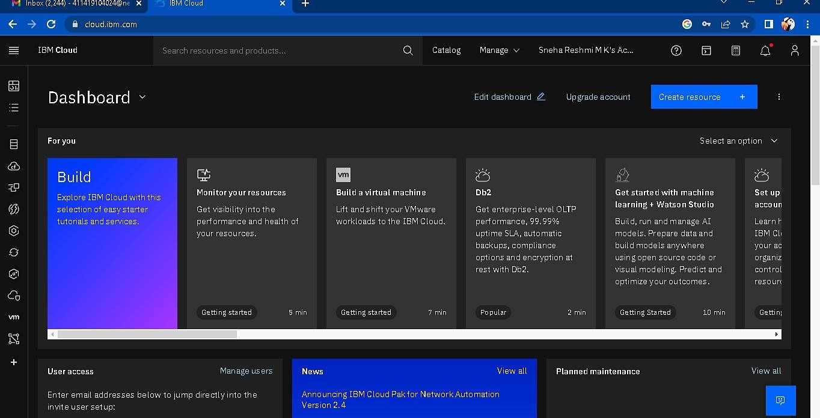

1. Search Cloudant in Catalog then Choose the Lite version

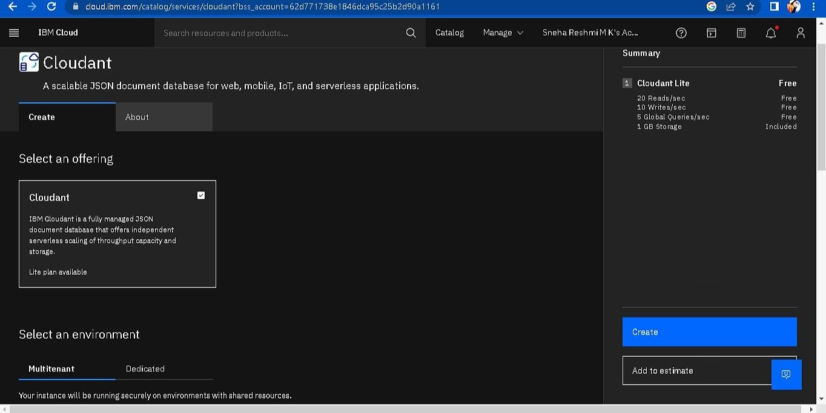

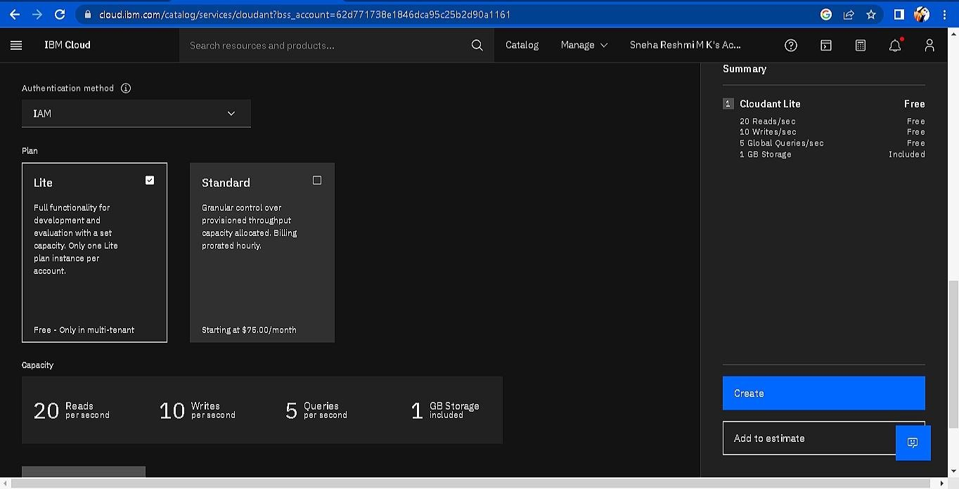

1. The Cloudant database resource created

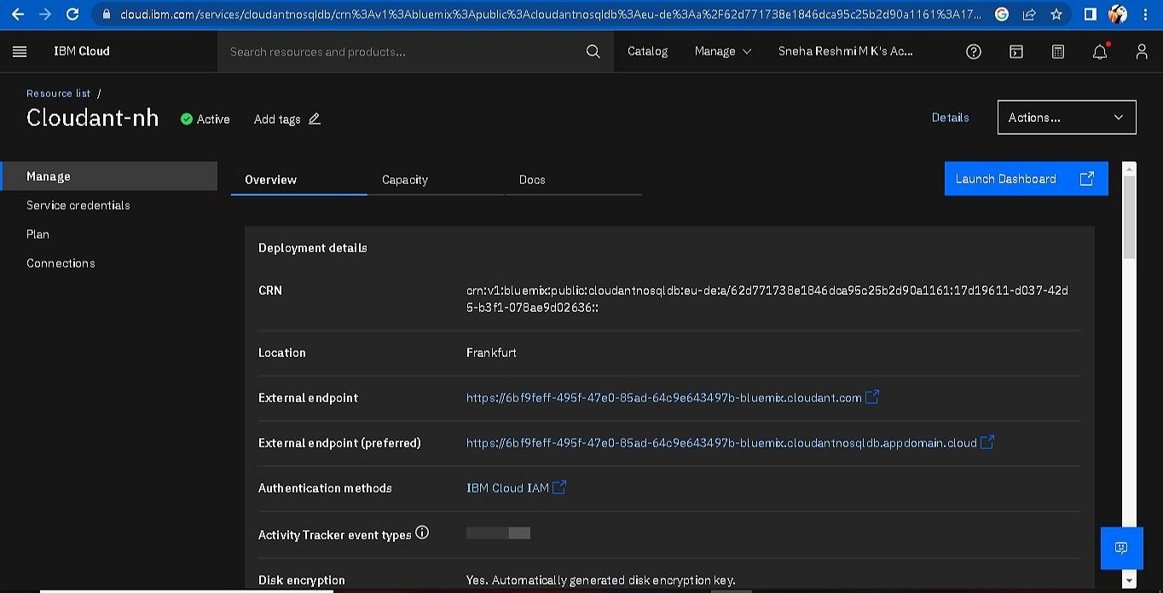

1. click on launch dashboard

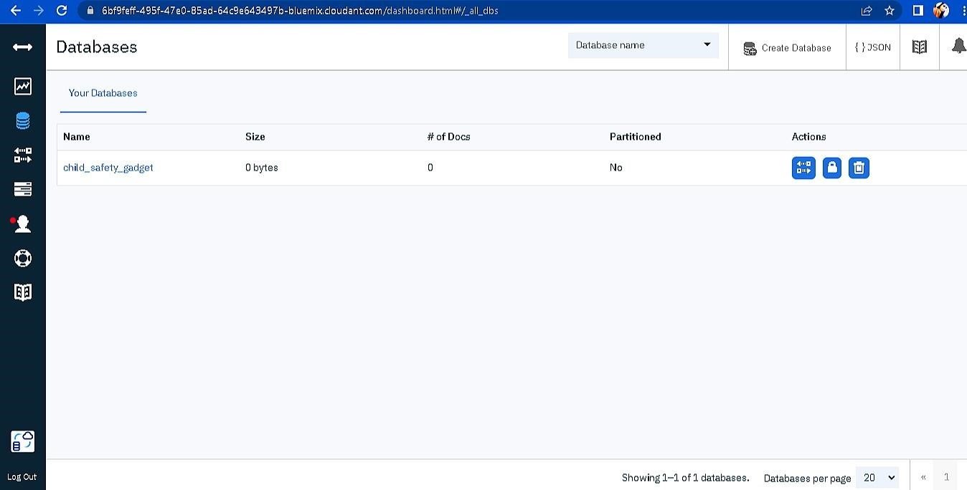

8.Click “Create Database”. Entered “child_safety_device” as the database name and the “Non-partitioned” option.

9. The database “child_safety_device” has been created and it's work Successfully

**RESULT**:

A database to store the location data on Cloudant DataBase has been created successfully.